ECA5610- Advance wireless communication systems

Name: S.Gokul
Reg no:192512373

Experiment Number: 1
Simulation and Comparative Analysis of FDMA, TDMA and CDMA:
Resource Allocation, User Capacity and Mobile-Generation Context

Aim:
To simulate and compare the basic resource-allocation methods used in FDMA, TDMA and CDMA, and examine how their assumed user capacity and interference behaviour differ.

Objectives:
- Model how FDMA, TDMA and CDMA allocate communication resources among users.
- Estimate and compare user capacity under stated assumptions.
- Plot how estimated CDMA SIR changes as the number of simultaneous users increases.
- Relate the access methods to representative mobile generations and interpret the limits of the simplified model.

Requirements:
  - Computer with MATLAB
  - No hardware is required

Program : for objective 1,2
% Comparison of FDMA, TDMA and CDMA
% Simplified illustrative model clc;
clear; close all;
% Illustrative system parameters
totalBandwidthHz = 1e6; % Total bandwidth: 1 MHz fdmaChannelHz = 200e3; % FDMA channel width: 200 kHz tdmaSlots = 8; % Number of TDMA slots per frame processingGain = 64; % CDMA processing gain targetSIRdB = 7; % Minimum acceptable CDMA SIR
% Capacity estimation
fdmaUsers = floor(totalBandwidthHz / fdmaChannelHz); tdmaUsers = tdmaSlots;
targetSIR = 10^(targetSIRdB / 10);
cdmaUsers = floor(1 + processingGain / targetSIR);
% Display estimated user capacity fprintf('Illustrative Maximum Supported Users\n'); fprintf('FDMA: %d users\n', fdmaUsers); fprintf('TDMA: %d users\n', tdmaUsers);
fprintf('CDMA: %d users at a target SIR of %.1f dB\n\n', ... cdmaUsers, targetSIRdB);
% Calculate CDMA SIR for different user counts K = 2:30;
sirLinear = processingGain ./ (K - 1); sirDb = 10 * log10(sirLinear);
% Create comparison table
method = {'FDMA'; 'TDMA'; 'CDMA'};
supportedUsers = [fdmaUsers; tdmaUsers; cdmaUsers]; results = table(method, supportedUsers);
disp(results);
% Plot 1: Estimated user capacity figure;
bar(categorical(method), supportedUsers); ylabel('Maximum Supported Users');
title('FDMA, TDMA and CDMA Capacity Comparison'); grid on;
% Plot 2: CDMA SIR versus number of users figure;
plot(K, sirDb, 'bo-', 'LineWidth', 1.5); hold on;
yline(targetSIRdB, '--r', 'Target SIR') xlabel('Number of Simultaneous CDMA Users (K)'); ylabel('Estimated SIR (dB)');
title('CDMA SIR versus Number of Users'); legend('Estimated SIR', 'Target SIR', 'Location', 'best'); grid on;
hold off;

Output:

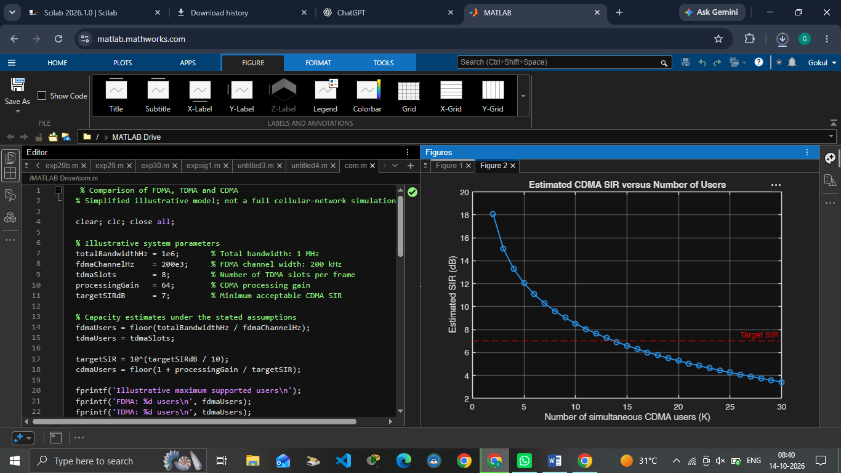
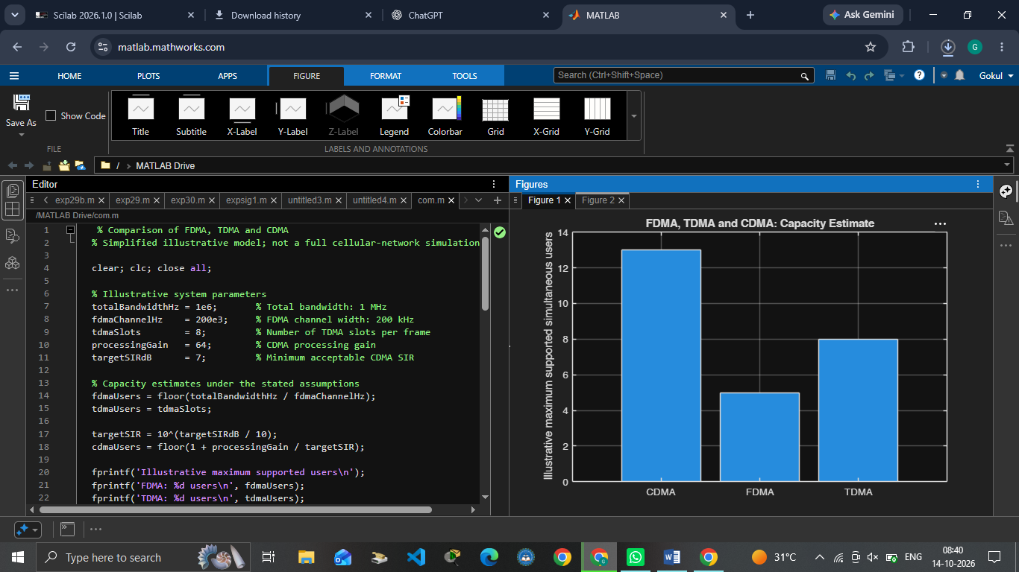+

OBJECTIVE 3:
Program :
generation = ["1G"; "2G"; "2G"; "3G"; "4G"; "5G"];
system = ["AMPS"; "GSM"; "IS-95"; "UMTS"; "LTE"; "5G NR"];
accessMethod = ["FDMA"; "TDMA"; "CDMA"; "WCDMA"; "OFDMA"; "OFDMA-based"];
keyIdea = ["Separate frequency channels"; ... "Separate time slots"; ...
"Code-based user separation"; ... "Wideband code-based access"; ... "Orthogonal frequency resources"; ... "Flexible OFDM-based radio access"];

evolutionTable = table(generation, system, accessMethod, keyIdea); disp(evolutionTable);
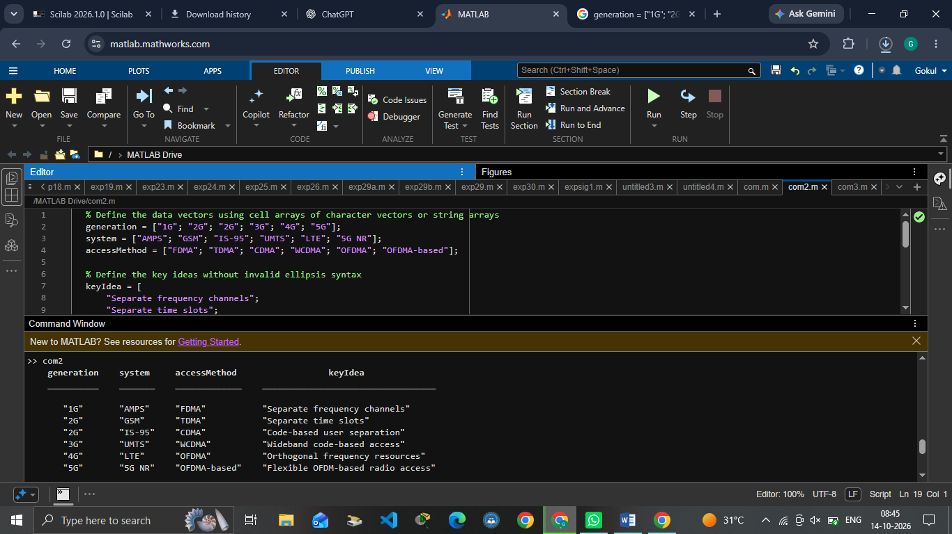

OUTPUT:

OBJECTIVE 4:

Program:
figure; tiledlayout(1,3);

% FDMA: users occupy different frequency channels nexttile;
hold on;
colors = lines(4); for u = 1:4
rectangle('Position',[0, u-1, 1, 0.8], ...
'FaceColor',colors(u,:), 'EdgeColor','k');
text(0.5, u-0.6, sprintf('User %d',u), ... 'HorizontalAlignment','center');
end
xlim([0 1]); ylim([0 4]); xlabel('Time');

ylabel('Frequency channel'); title('FDMA'); set(gca,'YTick',[]);
hold off;

% TDMA: users occupy different time slots on one frequency channel nexttile;
hold on; for u = 1:4
rectangle('Position',[u-1, 0, 0.8, 1], ...
'FaceColor',colors(u,:), 'EdgeColor','k');
text(u-0.6, 0.5, sprintf('User %d',u), ... 'HorizontalAlignment','center');
end
xlim([0 4]); ylim([0 1]); xlabel('Time slot'); ylabel('Frequency channel'); title('TDMA'); set(gca,'YTick',[]);
hold off;

% CDMA: users share the same time and frequency band using different codes nexttile;
hold on; for u = 1:4
rectangle('Position',[0, 0, 1, 1], ...
'FaceColor',colors(u,:), 'FaceAlpha',0.22, ...
'EdgeColor',colors(u,:), 'LineWidth',1.5);
end
text(0.5, 0.62, 'Users 1-4 share', 'HorizontalAlignment','center'); text(0.5, 0.40, 'band; different codes', 'HorizontalAlignment','center'); xlim([0 1]); ylim([0 1]);
xlabel('Time'); ylabel('Frequency band'); title('CDMA'); set(gca,'YTick',[]);
hold off;

sgtitle('Conceptual Time-Frequency Resource Allocation');

Output :

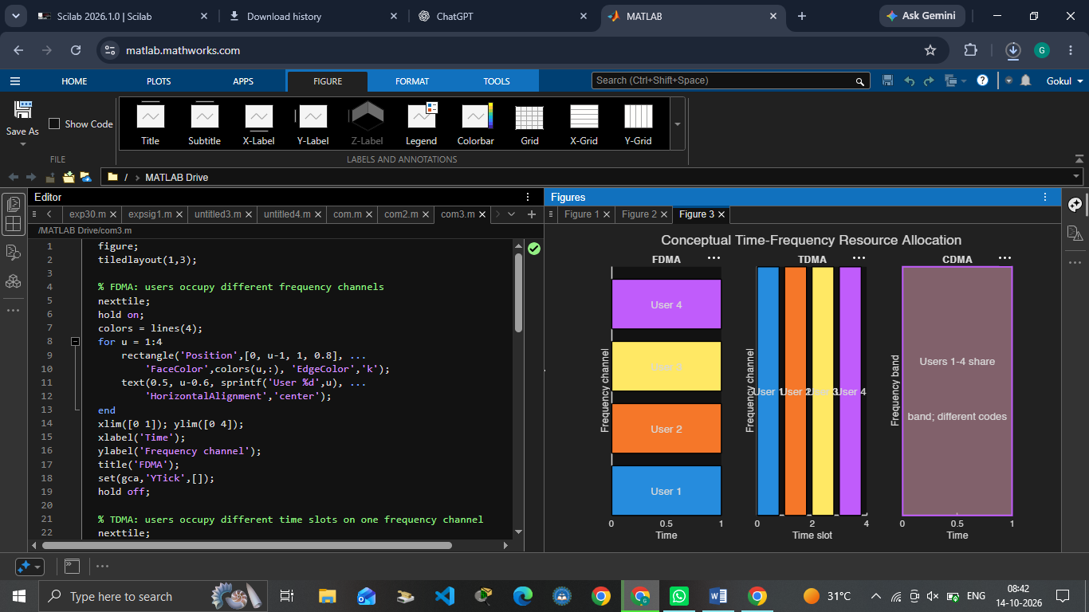

Result:
Thus, FDMA, TDMA and CDMA resource allocation techniques were studied and compared based on user capacity and signal-to-interference ratio.

